# Phase 9: Reporting, Dashboards & Security Review

## 1. Reports

- Create a Tabular Report (Accounts with Name & Phone)  
- Create a Summary Report (Opportunities grouped by Stage, Sum of Amount)  
- Glance at Matrix Report (Stage vs Owner cross-tab)  
- Glance at Joined Report (Accounts + Opportunities blocks)

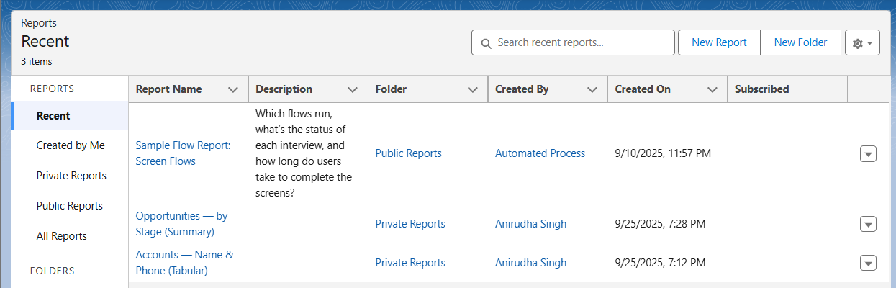  
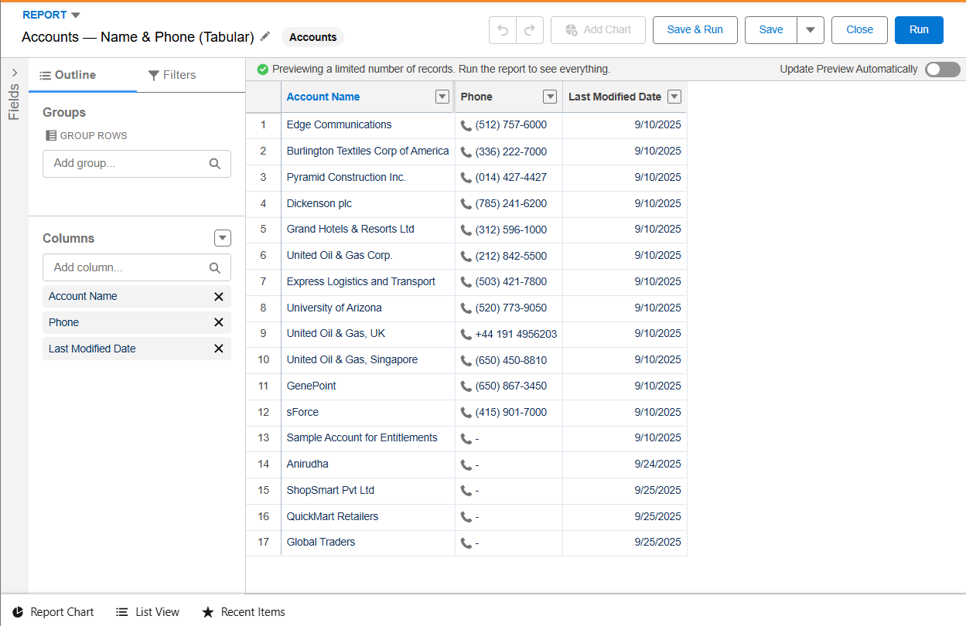  
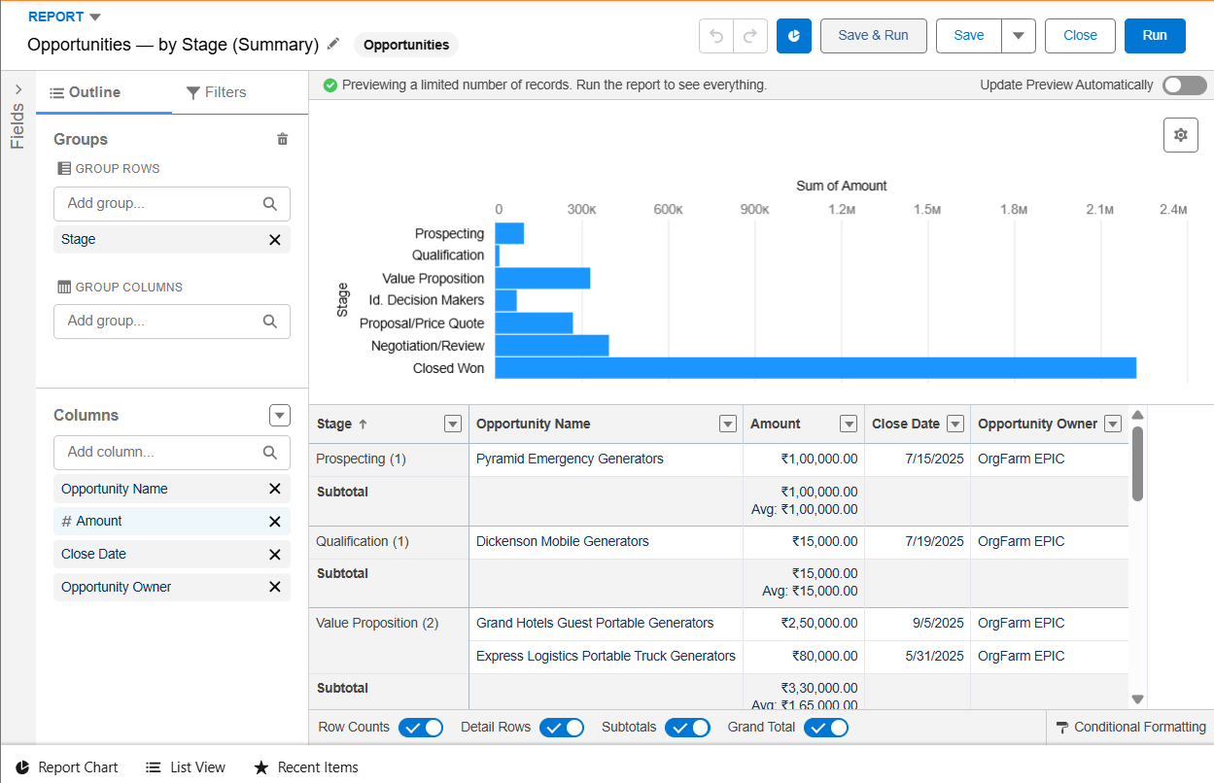  
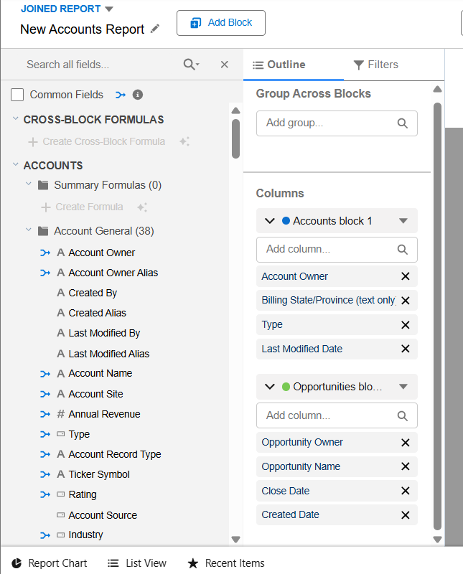

## 2. Report Types

- Used Standard Report Type (Accounts, Opportunities)  
- Created Custom Report Type: Accounts with Opportunities

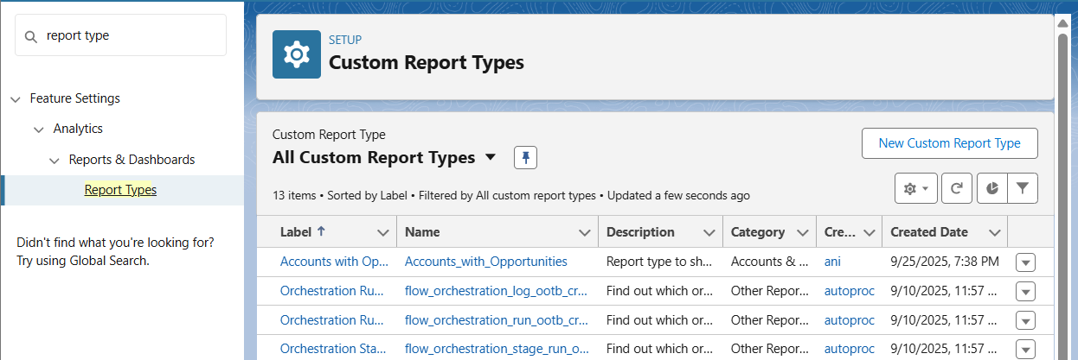  
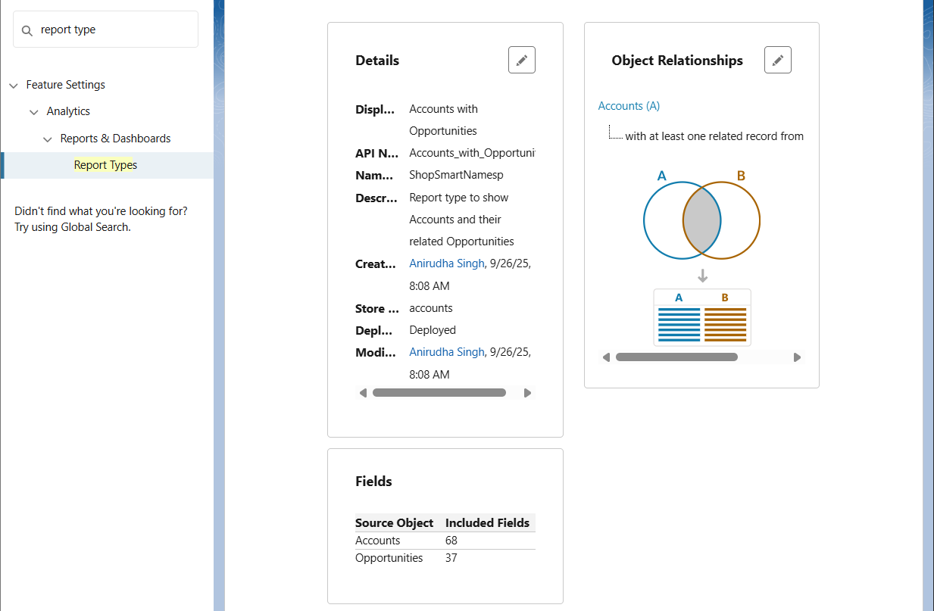

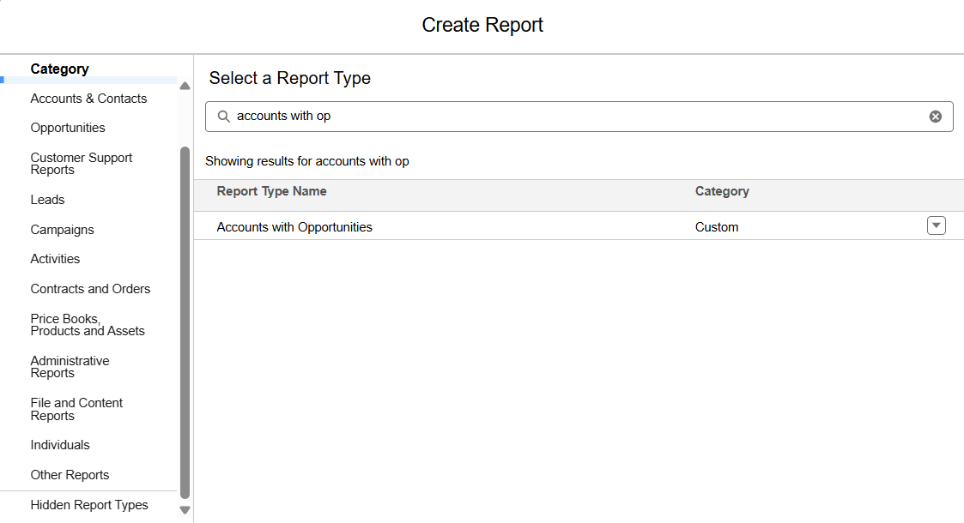

## 3. Dashboards

- Created Dashboard: 'Sales Performance Dashboard'  
- Added Component: Opportunities by Stage (Vertical Bar Chart)  
- Added Table Component (Accounts Tabular Report)

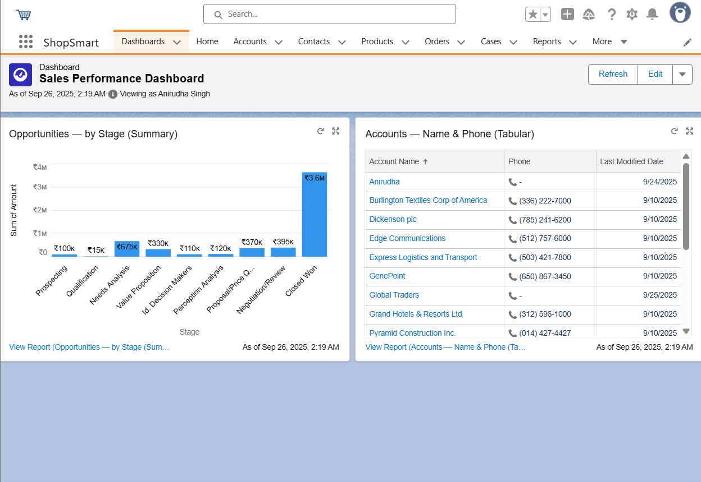

## 4. Dynamic Dashboards

- Edited Dashboard → Set 'View Dashboard As' = Logged-in User  
- Confirmed visibility differs by profile/role  
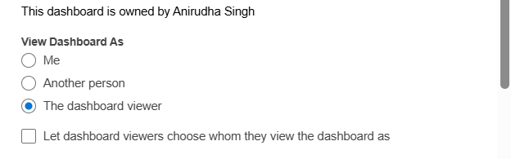

## 5. Sharing Settings

- Reviewed Org-Wide Defaults  
- Updated Accounts access to Public Read Only

- Created one Sharing Rule for demo

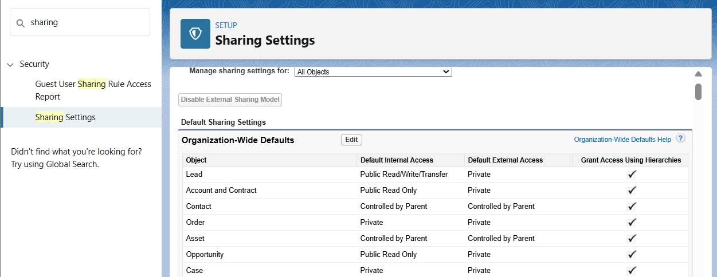

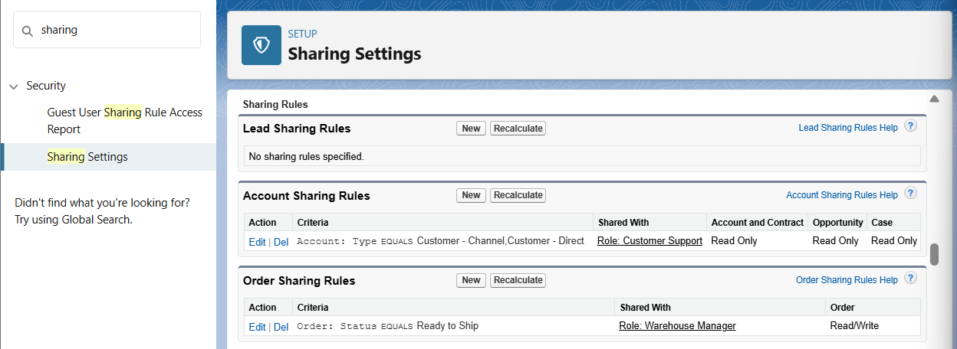

## 6. Field Level Security (FLS)

- Modified Account → Phone field visibility  
- Hid Phone field for Standard User profile  
- Confirmed field missing in reports for that profile

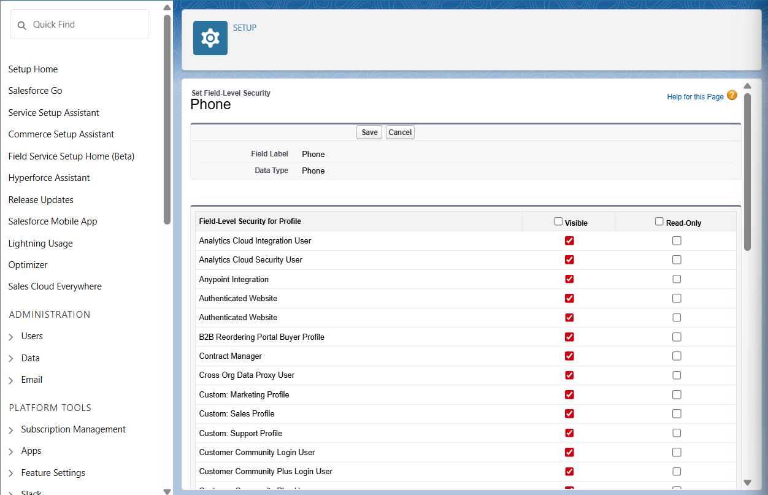  
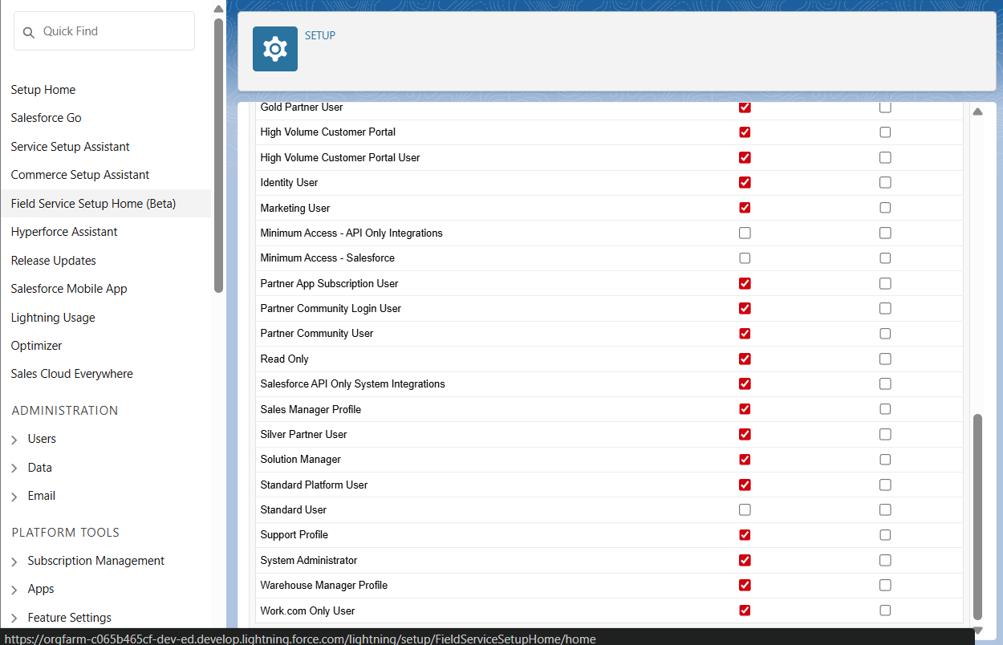

## 7. Session Settings

- Reviewed Session Timeout and login policies  
- Changed Session Timeout to 30 minutes  
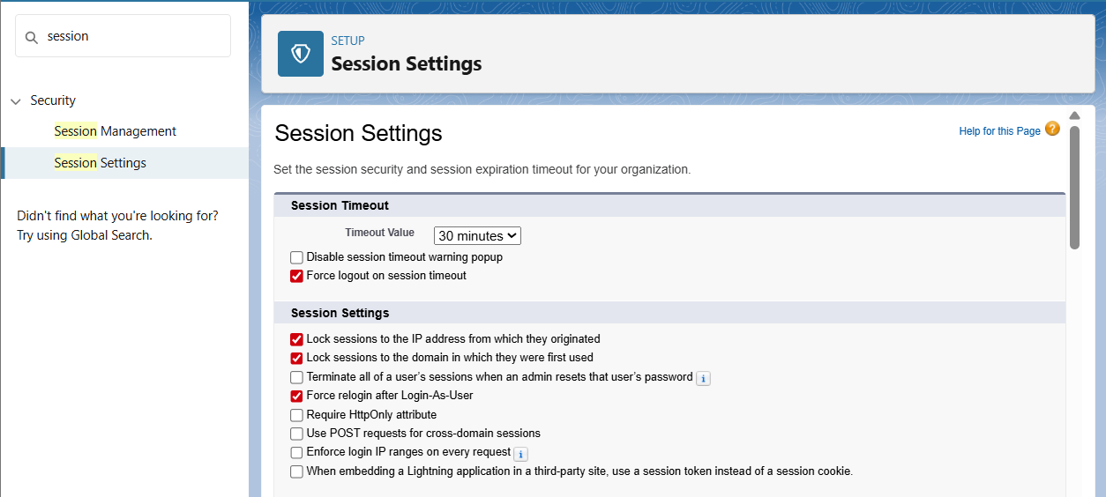

## 8. Login IP Ranges

- Added Login IP Range to System Administrator profile  
- Used 0.0.0.0 to 255.255.255.255 for testing  
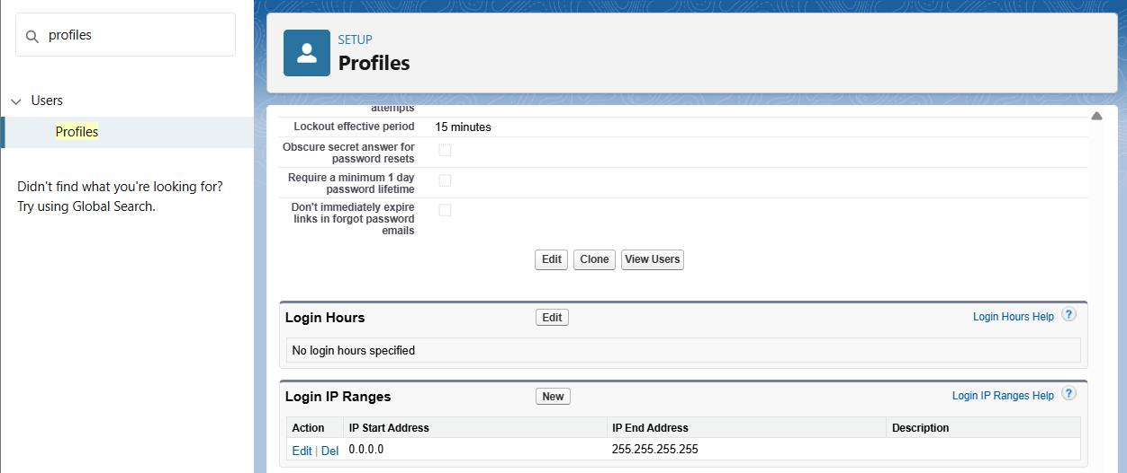

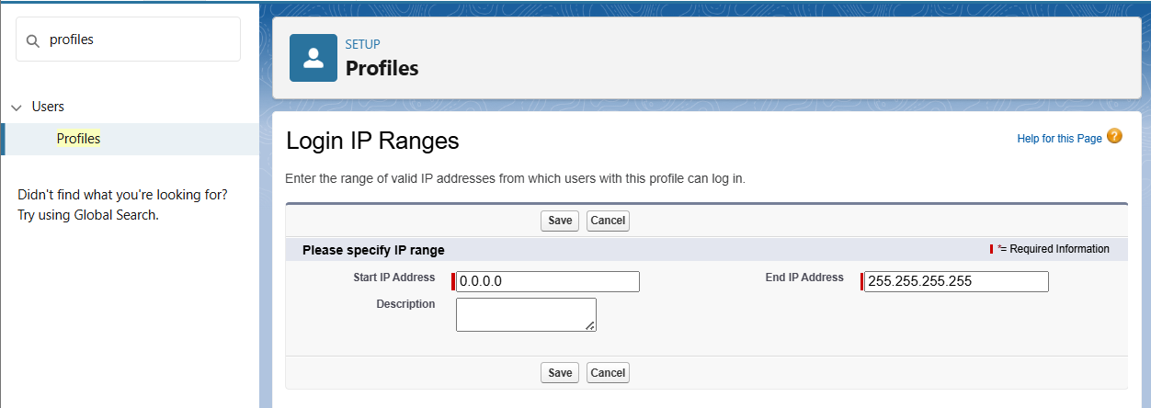

## 9. Audit Trail

- Viewed Setup Audit Trail (last 20 changes)  
- Exported full audit history (optional)  
